Please add your location to each of the following thematic maps.

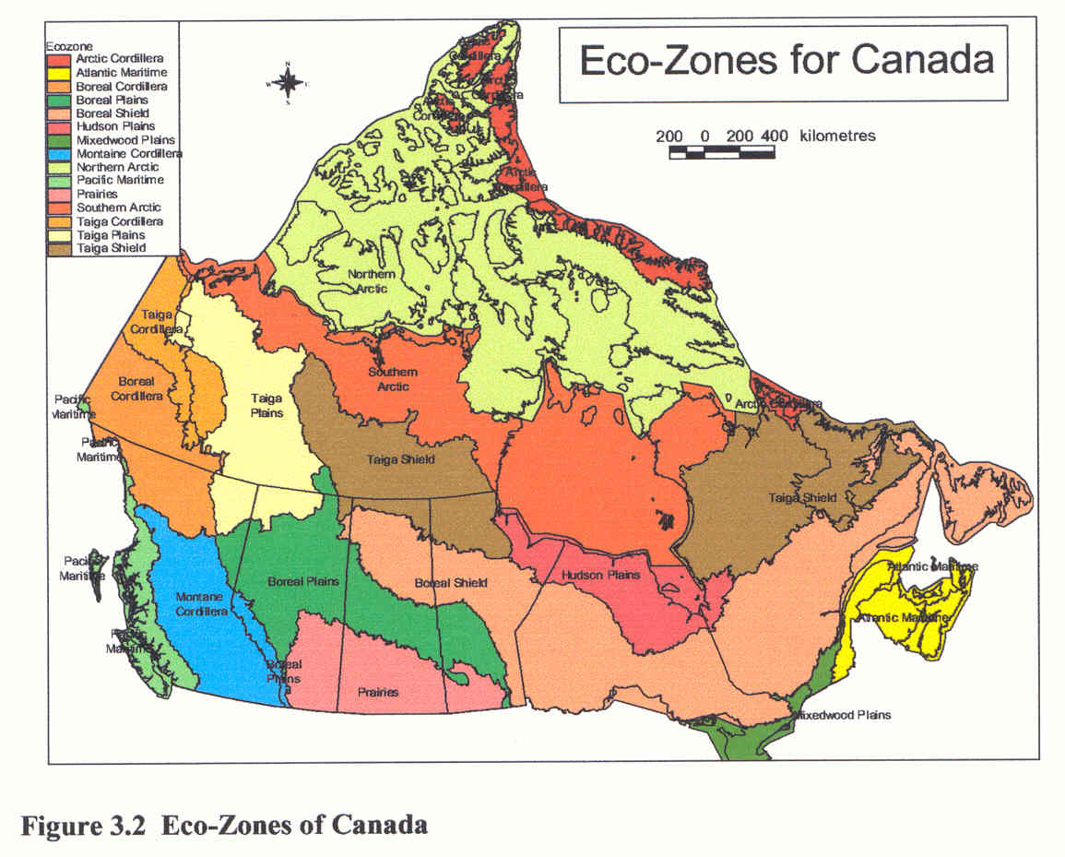

* **Cranbrook**

[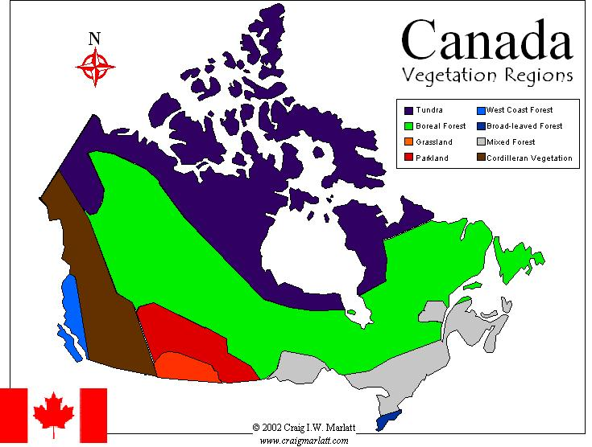](http://www.craigmarlatt.com/canada/images&downloads/downloads_maps_veg.html)

* **Cranbrook**

[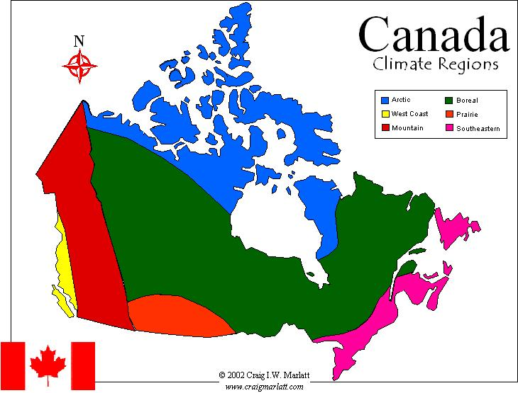](http://www.craigmarlatt.com/canada/images&downloads/downloads_maps_climate.html)

* **Cranbrook**

[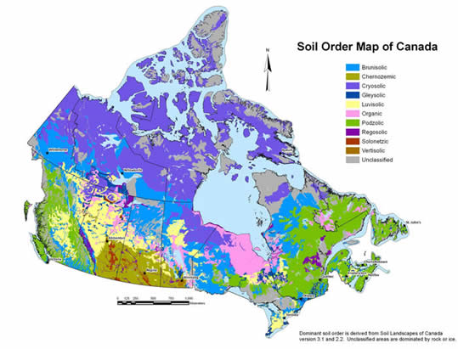](http://www.soilsofcanada.ca/images/Soil_Order_map.jpg)

* **Cranbrook**

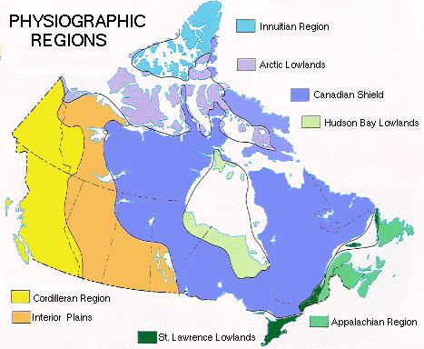

* **Cranbrook**