Population Pyramid - Cranbrook
Red Line – Cranbrook Blue solid - Canada
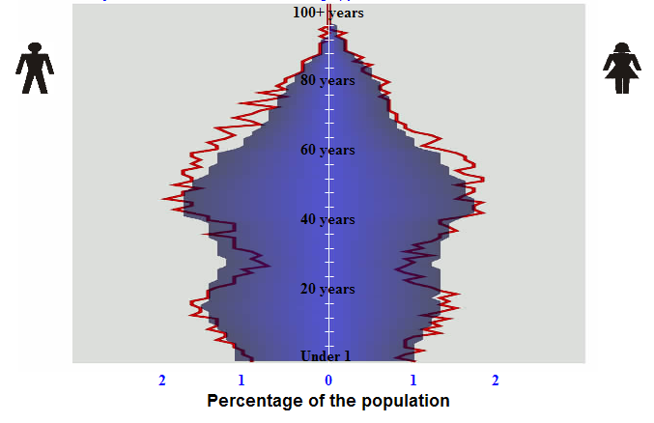
- Circle the appropriate answers below.
Birth rate – High or Low
death rate - High or Low
life expectancy – short or average or high
description of life – pyramid indicates that it is an industrialized area and people are older and having fewer children. Probably many retired people who are comfortable in living off their pensions.
- Which 20 year age category has the largest number of people?
0-20 20-40 40-60 60-80 80-100
- If you were a politician, what could you promise that 20 year category to get them to vote for you and explain why?
Education Employment Healthcare Pensions Housing Gender Immigration
Healthcare – as these people are getting older they will want to have good medical services in their area (doctors, hospitals, nurses, etc.)
Pensions – promises that their pensions will not be cut and will exist in the future will make these people feel more secure about being able to maintain their lifestyle.
Housing – promises to provide affordable seniors housing will make these people feel more secure because they will be able to access affordable housing and support in their old age.
- Compare and/or contrast Canada’s population pyramid to the pyramid for your city. If there are any obvious differences explain why. If there are similarities, explain the reasons for this as well.
The pattern for both pyramids are quite similar in shape. The bulge from 40-60 is the baby boom era and the small base is due to lower birth rates as we have more DINKS and SINKS. In the 20-40 category, Cranbrook is skinnier than Canada which would mean that perhaps there are fewer employment opportunites for younger people in this region and so they are having to go somewhere else to find work. Based on the age of the majority of people, they may be looking to retire soon which may create some job openings for people in the 20-40 age group.

