Population Pyramid Analysis
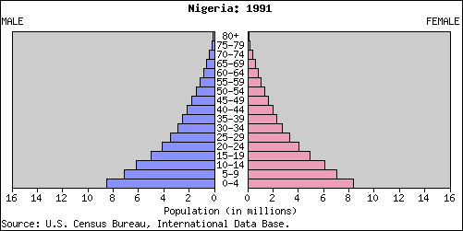 | Circle the appropriate answers below.  Birth rate – High or Low  death rate - High or Low  life expectancy – short or average or high  description of life – basic survival or becoming industrialized or industrialized  Important Issues to these people –  Education Yes or No  Employment Yes or No  Healthcare Yes or No  Pensions Yes or No  Housing Yes or No  Gender Yes or No  Immigration Yes or No
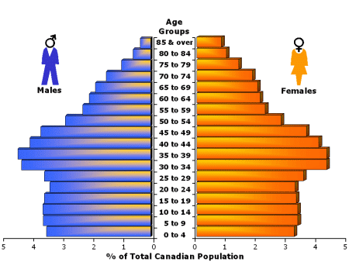 | Circle the appropriate answers below.  Birth rate – High or Low  death rate - High or Low  life expectancy – short or average or high  description of life – basic survival or becoming industrialized or industrialized  Important Issues to these people –  Education Yes or No  Employment Yes or No  Healthcare Yes or No  Pensions Yes or No  Housing Yes or No  Gender Yes or No  Immigration Yes or No
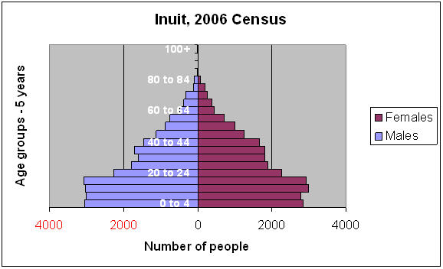 | Circle the appropriate answers below.  Birth rate – High or Low  death rate - High or Low  life expectancy – short or average or high  description of life – basic survival or becoming industrialized or industrialized  Important Issues to these people –  Education Yes or No  Employment Yes or No  Healthcare Yes or No  Pensions Yes or No  Housing Yes or No  Gender Yes or No  Immigration Yes or No

