Movie Resource - An Inconvenient Truth

Before Watching
Do you believe that the earth is warming? _______

If yes, do you think this will have any negative consequences and if so what do you think they will be?
__________________________________________________________________________________________________________________________________________________________________________________________________________________

If no, then how do you explain the earth’s recent warming trend?
__________________________________________________________________________________________________________________________________________________________________________________________________________________

The following vocabulary can be heard in the film an Inconvenient Truth Please match the words and phrases with the definitions in the table that follows.

Vocabulary Matching Exercise
Vocabulary |  | Meaning
1 | an iconic image | A | A day of judgement
2 | breach the levees | B | A type of paint to protect wood
3 | Canaries in the coal mine | C | A US Government official for health
4 | choc full | D | An important picture
5 | coat of varnish | E | Birds that fly to new places in autumn and spring
6 | connect the dots | F | Can be hurt
7 | day of reckoning | G | Educated guess
8 | hard-nosed | H | Go through the defences
9 | he intuited | I | He said he would regulate
10 | he pledged to regulate | J | Indicator of safety - Sent in before people are risked
11 | intellectual ferment | K | Lots of ideas
12 | irrigation | L | Majority of scientists agree
13 | meticulous | M | Mining without tunnels (Creates a lot of pollution)
14 | migratory birds | N | Put together the information
15 | open pit | O | Speed with direction
16 | scientific consensus | P | Surprising
17 | startling | Q | Tough, demanding
18 | Surgeon General | R | Very full
19 | velocity | S | Very thorough and careful
20 | vulnerable | T | watering plants on a farm

Answer Table – write the matching letter beside each number.
1 | 6 | 11 | 16
2 | 7 | 12 | 17
3 | 8 | 13 | 18
4 | 9 | 14 | 19
5 | 10 | 15 | 20

While Watching
Fill in the table below using words or images that represent the title of each column.
Evidence of Global Warming | The effects of Global Warming | What People can do to prevent it

After Watching
Read the quote below and look at the image. How do these two things explain our current human behaviour in relation to our action or inaction on global warming?
Quote (Upton Sinclair)
"It's difficult to get a man to understand something if his salary depends on him not understanding it."
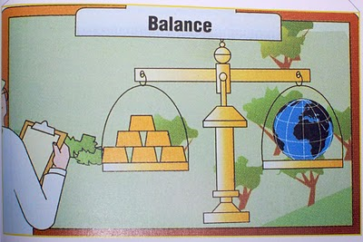
Image Answer
____________________________________________________________________________________________________________________________________________________________________________________________________________________________________________________________

List and describe three potential strategies that could be used to reduce carbon dioxide in the atmosphere.

Strategy | How it reduces Carbon Dioxide in the atmosphere.
1.
2.
3.

