Your Ecological Footprint
In each of the footprints below, draw images or write words on or around each footprint to represent what your actual footprint would contain for each of the four areas.

Shelter Food
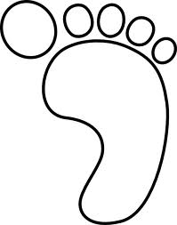

Mobility Goods and Services
A Greener Ecological Footprint
In the footprints below, draw images or write words on or around each footprint to represent things that would make your footprint for each of the four areas smaller and greener.

Shelter Food

Mobility Goods and Services

