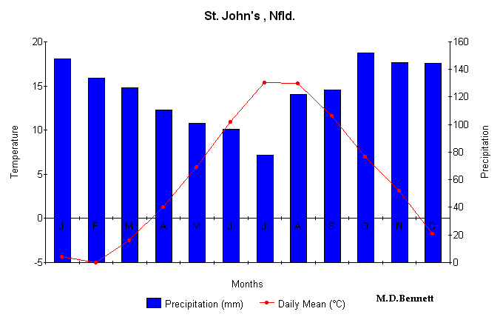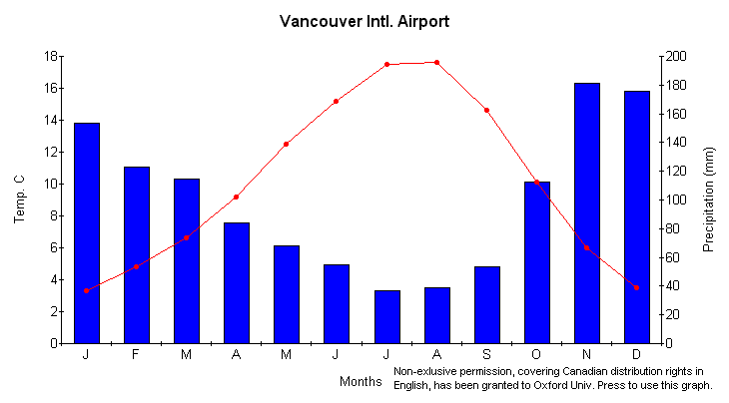
Get together with a partner. You will each choose one of the Climate Graphs above and complete the table below.
Write a description for the following….  Winter Temp:  Summer Temp:  Precipitation:  -----------------------------------------------------------------------------  Fill in the numerical data for the items below.  Growing Season (# months):  Max Temp:  Min Temp:  Temperature Range:  ------------------------------------------------------------------------------  Is this location affected by water? (Circle) Y or N  Provide support for your answer.  ------------------------------------------------------------------------------  Which air mass(es) impact this region?  Cause of the precipitation (circle)  orographic, frontal or convection  ------------------------------------------------------------------------------  Describe or draw a diagram that includes words to illustrate how it causes the precipitation. (P. 135-139) | Write a description for the following….  Winter Temp:  Summer Temp:  Precipitation:  -----------------------------------------------------------------------------  Fill in the numerical data for the items below.  Growing Season (# months):  Max Temp:  Min Temp:  Temperature Range:  ------------------------------------------------------------------------------  Is this location affected by water?  Provide support for your answer.  -----------------------------------------------------------------------------  Which air mass(es) impact this region?  Cause of the precipitation (circle)  orographic, frontal or convection  ------------------------------------------------------------------------------  Describe or draw a diagram that includes words to illustrate how it causes the precipitation.

