Canada – Provinces, Territories, Capitals, Major Water Bodies and Oceans
Label the map below with the names of the provinces, territories, capitals, major water bodies and oceans.
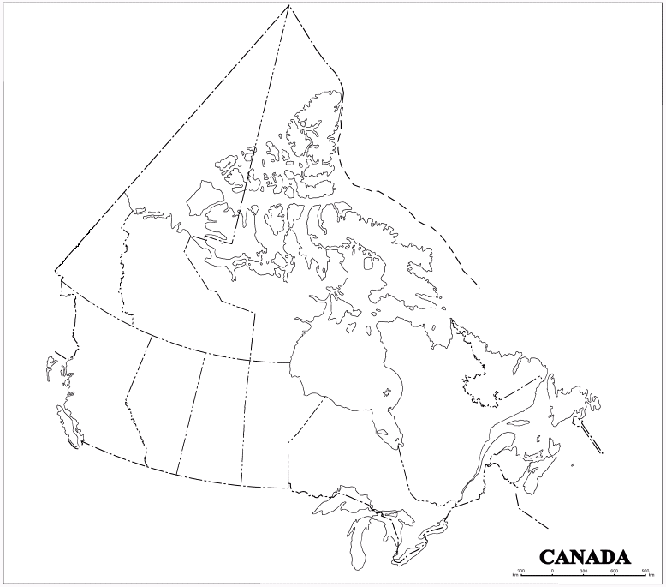
Provinces and Territories | Capitals | Water Bodies and Oceans
Newfoundland and Labrador | Iqaluit | Pacific
Prince Edward Island | Whitehorse | Atlantic
New Brunswick | Yellowknife | Arctic
Nova Scotia | Victoria | Lake Ontario
Quebec | Edmonton | Lake Huron
Ontario | Regina | Lake Superior
Manitoba | Winnipeg | Lake Erie
Saskatchewan | Toronto
Alberta | Quebec City
British Columbia | Frederiction
Yukon | Charlottetown
Northwest Territory | Halifax
Nunavut | St. John’s

